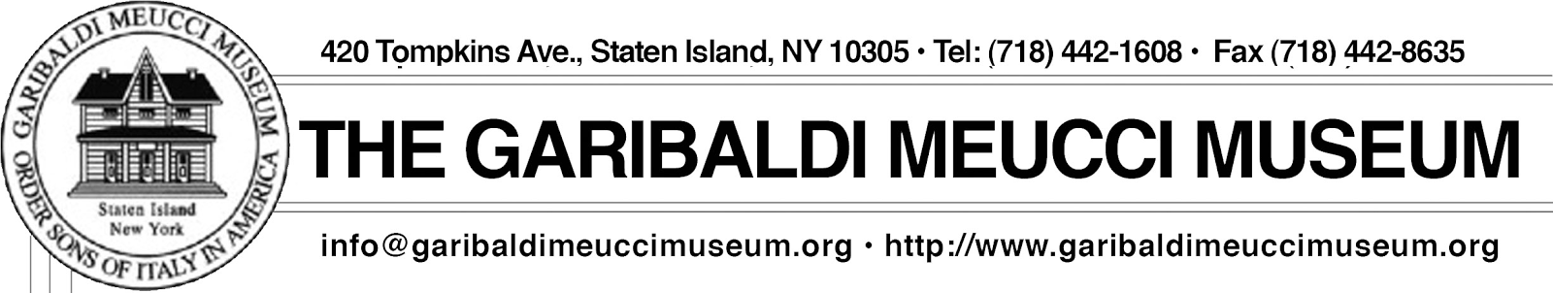
NEW WEBSITE www.garibaldimeuccimuseum.com

“Italian opera: A Reflection of life!”
An opera class at the garibaldi meucci museum
with professor lou barrella
SPRING TERM 2020
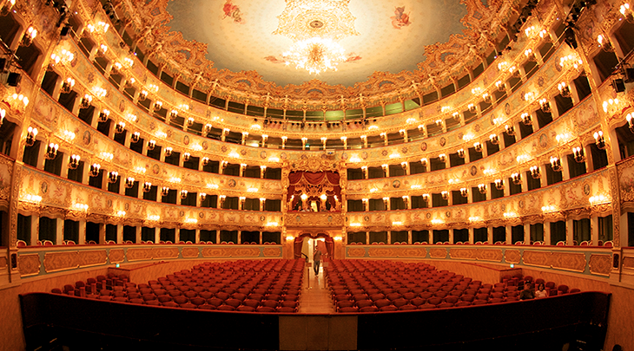
This 6 week class will elicit an appreciation for both seasoned opera lovers and new-comers alike. It intends to excite the appetites of all those who especially love Italian Opera by gaining insights into the minds and souls of the composers whose works still affect us today. Now in its 10th season, this is not a repeat course. All sessions are new and there is no prerequisite for newcomers. Join us for an experience of intellectual stimulation and musical pleasure.
The classes will run on Wednesdays, April 15th through May 20^{h} from 1:30 to 3PM.
A Tale of Two “Manons” (Operas by Puccini and Massenet) Part 1
A Tale of Two ”Manons” (Operas by Puccini and Massenet) Part 2
Card Playing Scenes in Opera
Verdi’s Coloratura Sopranos
Revisiting the first Three Tenors Concert.
Waltzing at the Opera

$125 for Non-members and $110 for Members
___________________________________________________________________________________________________________________________________

Name: _________________________________________ Credit Card Type: _________________________________________
Address: ______________________________________ Card Number: _________________________________________
Phone: ________________________________________ Security Code: _________________________________________
Email: _________________________________________ Exp. Date: _________________________________________
Manner or Payment: _________________________ Make Checks Payable to: The Garibaldi Meucci Museum

We Thank the following Foundations, Organizations and Private Sponsors who have Supported and Funded our School Programs and Cultural Events
NYS GRAND LODGE FOUNDATION INC. & SONS OF ITALY FOUNDATION

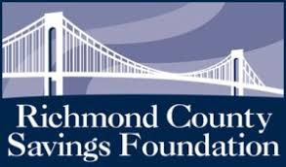

2

