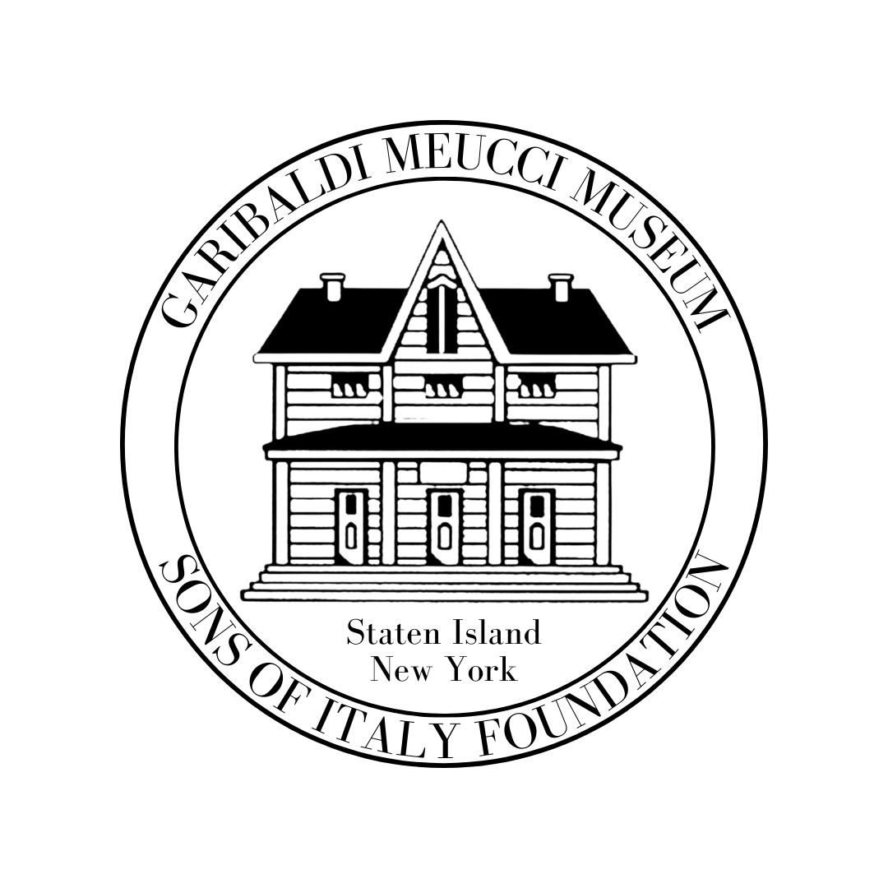
THE GARIBALDI-MEUCCI MUSEUM
420 Tompkins Ave. Staten Island NY 10305 Tel: (718) 442-1608 Fax (718) 442-8635
info@garibaldimeuccimuseum.org http://www.garibaldimeuccimuseum.com

Italian Language Courses Fall 2022 Semester
Have You Been Thinking About Learning Italian? Benvenuti!
Learn Italian at one of the oldest Italian American Cultural Centers in the
United States, the home of Antonio Meucci and his house guest
Giuseppe Garibaldi.
All classes are held at the Garibaldi-Meucci Museum 420 Tompkins Avenue, Staten Island, NY 10305

For your safety we follow all updated NYC CDC Guidelines
The museum is wheelchair accessible to its grounds and first floor.
A wheelchair accessible porta-a-san is also available for visitors’ comfort.

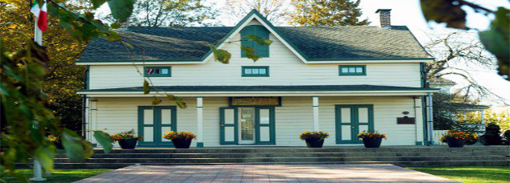

10 Week Fall Semester Class Begins in September 2022

Italian Language Level III Class:
Teacher: Rose Frisari
Time: 11:30 a.m.-1:00 p.m.
Starting Tuesday 9/20
Ending Tuesday 11/29/22
No class on Nov. 22, for Thanksgiving week

This class is designed for students who know basic Italian with one or more
years of study in the structure of
the language. We will move on to
new vocabulary, verbs and grammatical structure. More time will be dedicated
to listening, speaking, reading and writing so that we can learn to master
la bella lingua.

Advanced Italian Class:
Teacher: Bartolomeo Regine
Time: 5:00 p.m. - 6:30 p.m.
Starting Mon. 9/19
Ending Monday 11/21/22

This class is designed for students who have a good proficiency of Italian and wish to expand their knowledge of the language. Students will have the opportunity to read and discuss contemporary Italian topics and engage in discussions.

“Conducted Entirely in Italian”

Italian Language Level I/II Class:
Teacher: Prof. Louis Leonini
Time: 11:30 a.m.-1:00 p.m.
Starting Sunday 9/18 Ending Sunday 11/20/22

This is a course specifically designed for beginners emphasizing basic vocabulary, everyday phrases and conversational dialogues aimed at giving the students the confidence
in their ability to speak Italian.
The course includes cultural and historical highlights that will
enhance the student’s to
understand Italy.
and its people.

8 Plus Students

$200 for Non-Members/$185 Museum Members (Must Be Paid in Advance)
(90-minute classes) Each Class must have 10 Students

---------------------------------------------------------------------------------------------------------------------------------------------------------
Registration Form/For More Info or to Pay by Credit Card
Call 718-442-1608
Name:_______________________________________________________

Address: _____________________________________________________

Email_______________________________________________________

Home Phone: ___________________ (Cell Phone) ___________________

Manner of Payment: Check ______ Credit Card_______

Number_____________________________________________________

Security Code: __________________ Exp. Date: _____________________

Make Checks Payable To: Garibaldi-Meucci Museum

CHECK THE BOX TO REGISTER

Italian Language Level I/II Class Prof. Louis Leonini

Italian Language Level III Class
Rose Frisari

Advance Italian Conducted Entirely in Italian
Bartolomeo Regine

