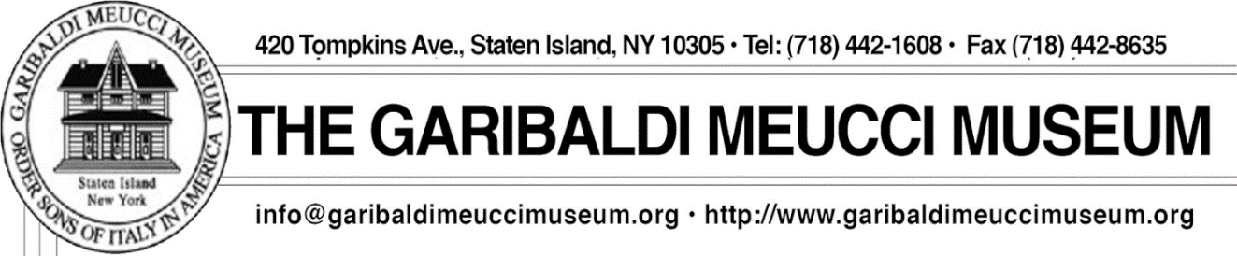
NEW WEBSITE www.garibaldimeuccimuseum.com
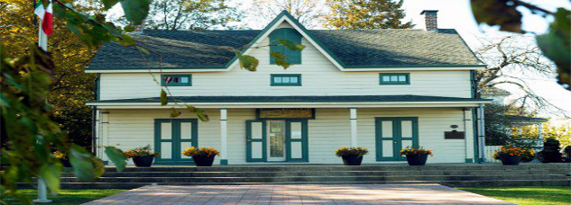

Italian Language Courses 2020 Spring Semester

Have You Been Thinking About Learning Italian? Benvenuti! Learn Italian at one of the oldest Italian American Cultural Centers in the United States, the home of Antonio Meucci and his house guest, Giuseppe Garibaldi.
The 12-week semester begins the week of February 23, 2020 with 90-minute classes offered weekdays, evenings and weekends to accommodate most schedules, for students of all levels of proficiency.
Tuition is $200 for non-members and $185.00 for museum members and must be paid in advance.
All classes are held at The Garibaldi-Meucci Museum
420 Tompkins Avenue, Staten Island, NY 10305

LEVEL I
This course is designed for new students, and also for students who have some knowledge of Italian but require the structure needed to be able to speak, read and write Italian.
Sundays: 11:00 AM to 12:30 PM
Begins Sunday February 23, 2020
Professor L. Leonini

LEVEL I
(For students who have little or no knowledge of Italian).
Students will learn vocabulary, verbs and grammatical structures needed for speaking and writing our beautiful language.
Tuesdays: 2:00 PM to 3:30 PM
Begins Tuesday February 25, 2020
Professoressa R. Frisari
(waiting list only)

LEVEL III
(For students who have studied Italian for at least two years and have a basic background in the study of the language).
These students will build on their basic foundation and will move forward on their speaking and writing skills. They will learn new vocabulary, verbs and grammatical structures.
Wednesdays: 11:30 AM to 1:00 PM
Begins February 26, 2020
Professoressa R. Frisari
(waiting list only)

ADVANCED
Course is designed for students who have taken fundamental Italian classes and wiill develop further proficiency in conversational Italian.
Saturdays: 11:30 AM to 1:30 PM
Begins Saturday February 29, 2020
Professor L. Leonini

Advance Italian
Conducted Entirely in Italian
This course is designed for students who are fluent in spoken Italian and possess a good foundation in Italian grammar. Students will have the opportunity to practice and expand their knowledge of the beautiful language.
Mondays, 5:00 PM to 6:30 PM
Begins Mondays February 24, 2020
Professor Bartolomeo Regine

Registration Form:

Name:___________________________________________________________________________________

Address: ________________________________________ Email____________________________________

Home Phone: __________________________ (Cell Phone) ________________________________________

Manner of Payment: Check ______ Credit Card_______

Credit Card Type: ______________________

Card Number_________________________________________

Security Code: ______________________

Exp. Date: _________________________

Make Checks Payable To: The Garibaldi Meucci Museum

Please select level, day, time and Professor:

(Level I ______ ) (Level II_______ ) (Level III_______) (Advanced Class______ )

Day and time: _____________________________________________________

Professor: ________________________________________________________

For more information please call the museum: 718-442-1608
All materials needed for classes will be discussed in the first session.

Please note, we are located in a residential neighborhood. Museum entrance is located on Chestnut Street.
Museum is wheelchair accessible on the first floor. Museum bathroom is located on the second floor.

