THE GARIBALDI-MEUCCI MUSEUM
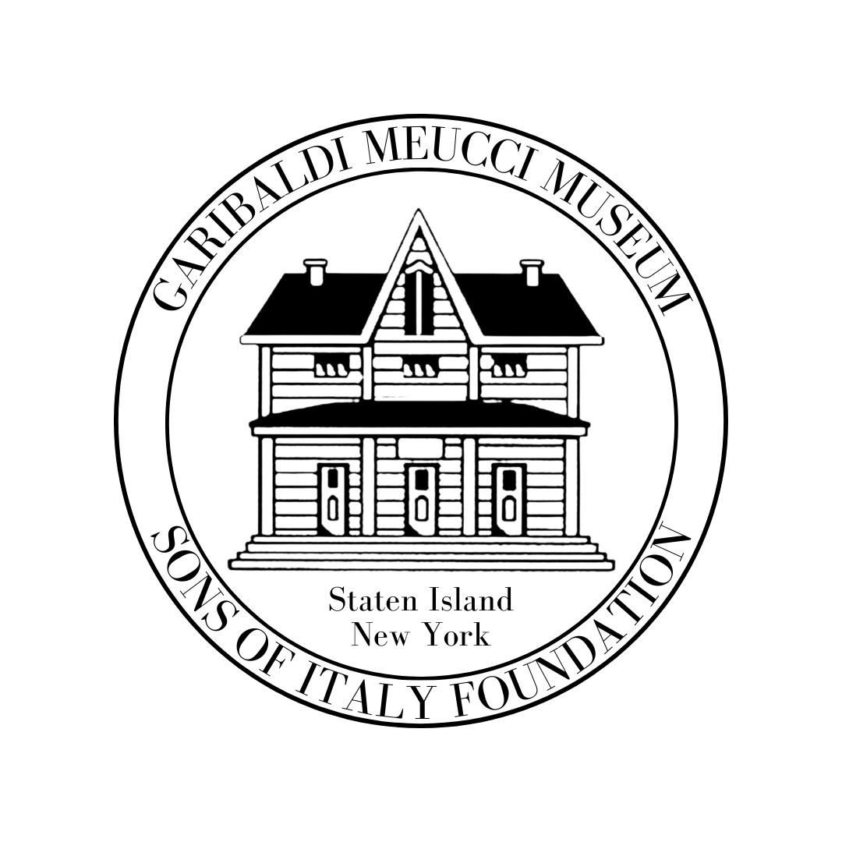
420 Tompkins Ave. Staten Island NY 10305 Tel: (718) 442-1608
info@garibaldimeuccimuseum.org http://www.garibaldimeuccimuseum.com

“Italian opera: A Reflection of life!”
An opera Lecture Series at the garibaldi-meucci museum
with professor lou barrella
FALL TERM 2022
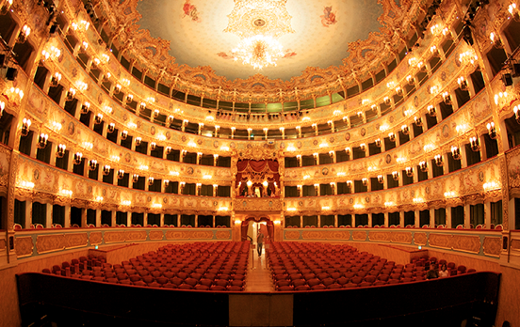
This 6-week class will elicit an appreciation for both seasoned opera lovers and new-comers alike. It intends to excite the appetites of all those who especially love Italian Opera by gaining insights into the minds and souls of the composers whose works still affect us today. Now in its 10th season, this is not a repeat course.
Classes will Start Tuesday, October 11th and End on November 8. 2022 from 1:30 to 3pm. Members $125/Non Members $135 All sessions are new and there is no prerequisite for newcomers. Join us for an experience of intellectual stimulation and musical pleasure.
- October 11th – The Joy of Opera: A Reflection of Life
- October 18th - Card playing Scenes in Opera
- October 25th - Verdi’s “Rigoletto” – Part 1
- November 1st - Verdi’s “Rigoletto” – Part 2
- November 8^{th -} Verdi’s “Love Triangle” Trios
- November 15th - Variations on Bizet’s “Carmen”
BONUS: We also have seats for the MET Opera Dress Rehearsal of Verdi’s “Rigoletto” on
Monday, November 7th.

***************************************************************************************************************************************************************************************
Registration Form/For More Info or to Pay by Credit Card Call 718 442 1608
(Make Checks Payable To: Garibaldi-Meucci Museum
Name:__________________________________________________________

Address: _______________________________________________________________________________________

Email________________________________ Home Phone: __________________(Cell Phone)__________________

Manner of Payment: Check ______ Credit Card_______

Number_____________________________________________________Security Code: __________ Exp. Date: _____________ _____________________
For your safety we follow all updated NYC CDC Guidelines
The museum is wheelchair accessible to its grounds and first floor. A wheelchair accessible porta-a-san is also available for visitors’ comfort.

